Physics 30 Lesson 15 Electric Fields

# Fields

The idea of a **field**resulted from a need to explain how one object (for example a charged ebonite rod) can have an effect on another object (a charged pith ball) over a distance. How does the pith ball “know” about the presence of the ebonite rod? Conversely, how does the ebonite rod “know” about the presence of the pith ball? After all, they are not in direct contact.

It is this “action at a distance” for which the concept of a field was initially developed. In this course we will learn about electric fields and magnetic fields (Lesson 19). We learned about gravitational fields in Physics 20.

# Electric fields

An **electric field** is generated by any object which has an electric charge. Electric fields have the following characteristics:

1. Electric fields can be produced by either positive or negative charged objects.
2. Electric fields decrease in strength with increased distance.
3. Electric fields are vector fields.

When a charge (q) is placed within an existing electric field it will experience a force. The electric field strength () at a given point is defined as the ratio of the electric force () to the magnitude of the charge (q).



Notice that the electric field strength equation above uses absolute value symbols. The equation calculates the **electric field strength**, but does not give its direction. The direction of an electric field at any point in space is conventionally defined as: **the direction that a small imaginary positive test charge (qT) will move in the electric field**. We imagine that the charge on qT is so small that it responds to the electric field without changing the electric field being tested.

+

qT

The positive test charge will be repelled by a positive charge ( is positive)

The positive test charge will be attracted to a negative charge ( is negative)

–

qT

A 60 C charge is placed in an electric field. If the mass of the charge is 0.25 mg and it experiences an acceleration of 1.25 x 104 m/s2, what is the electric field strength at that point?

Find the force on the charged particle Calculate the electric field strength



# Electric field strength around a point charge

The electric field strength for a point charge source is given by the equation:



The electric field is generated by a charge **q**. The larger the charge, the greater the strength of the electric field around the charge. In addition, the further we go from the charge, the weaker the electric field strength becomes. Point charges or charges on spheres produce **non-uniform electric fields**.

If the electric field is 6.0 x 108 N/C toward a point charge at a distance of 5.0 cm from the centre of the charge, what is the magnitude and sign of the charge?

Since the electric field is directed toward q (i.e. a positive test charge is attracted to q) q must be negative.



When two charges are involved, the resulting electric field is the **vector sum of the fields from each of the charges**. For example, say we have a positive and a negative charge a fixed distance from each other. At any point (P) in space, the resulting electric field will be the vector sum of the electric fields of each of the two charges.

•

–

P

+



+

–

A +40 C charge and a –60 C charge are set 1.0 m apart as shown in the diagram. Calculate the electric field (magnitude and direction) at a point 0.25 m to the left of the +40 C charge.

+40 C

–60 C

0.25 m

1.0 m

When solving this problem it is extremely important to draw a diagram showing the directions of the electric fields of all the charges generating the field at the point of interest. Recall that the direction of the electric field is the direction that a small + test charge would move if placed at the point of interest. A positive test charge would be attracted to the –60 charge and away from the +40 charge.



 



From the diagram below determine (a) the electric field at point P and (b) the electrostatic force on a –3.00 nC charge if it were placed at P.

•

•

•

P

–2.00 C

0.10 m

0.075 m

+4.00 C

The electric field at P is the vector sum of the electric fields from both charges .



❑

1.798 x 106 N/C

The vector diagram is:

639289 x 106 N/C



(b) the force on a –3.00 nC charge at P

Note that a negative charge moves in the opposite direction in an electric field than a positive charge would move.



# Electric field diagrams

It is useful to visualize the direction and strength of an electric field at various points in space as a "map." The great English physicist Michael Faraday (1791–1867) proposed the idea of *electric field lines* or *lines of force*. The photograph to the right shows bits of fine thread suspended in oil. At centre is a charged object. Its electric field induces opposite charges on the two ends of each bit of thread which then tend to line up end-to-end along the direction of the field lines. The diagrams below show how we draw the field lines around a point charge. Note the direction of an electric field is away from positive and toward negative.

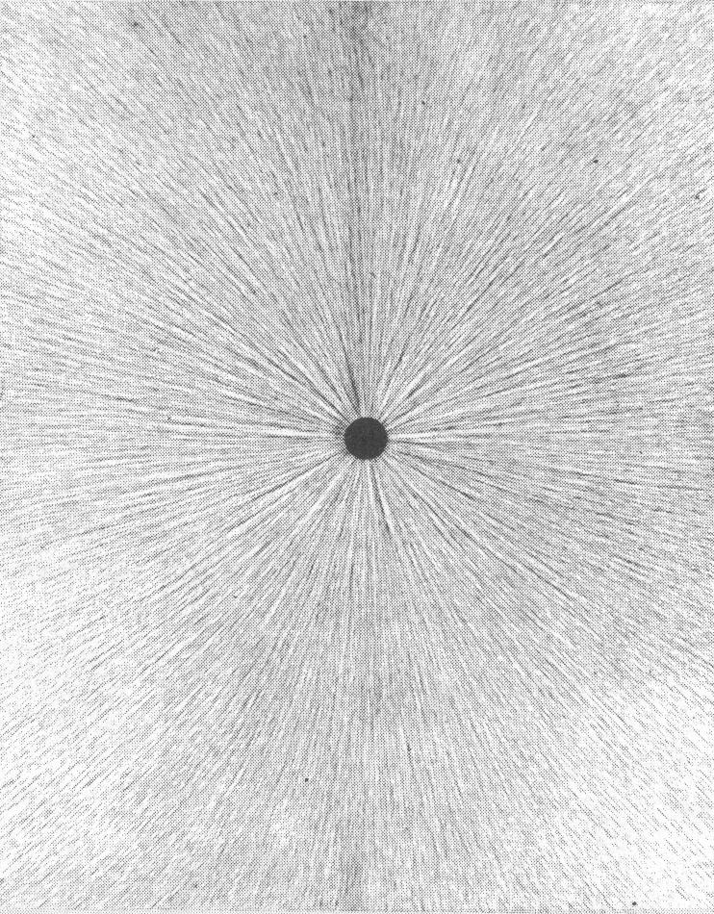

Cotton fibres floating in oil respond to a point charges.

–

+

As we saw in the examples above, when two or more charges are creating an electric field the result is the vector sum of the fields from all of the charges. Thus, when we have equal positive and negative charges the following electric field is produced.

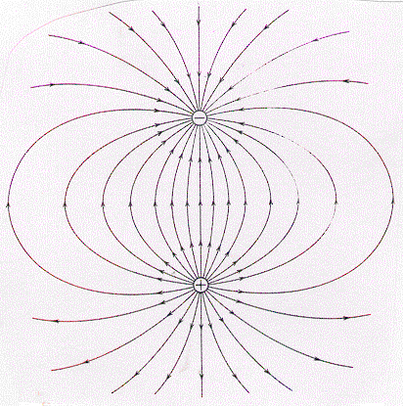

Cotton fibres floating in oil respond to + and – point charges.

Sketch of electric field lines due to + and – point charges.

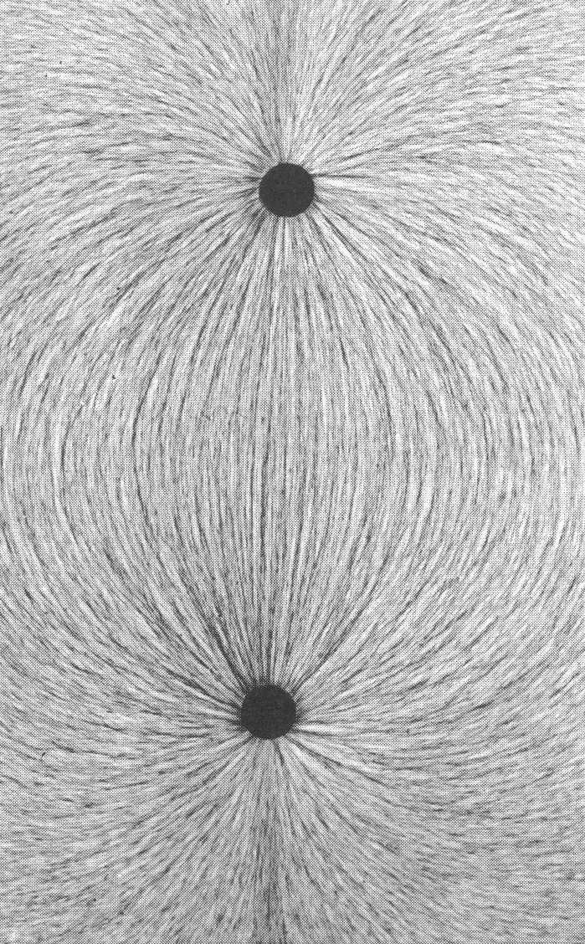

In summary:

1. Electric field lines are directed away from positive charges and toward negative charges.
2. The number of field lines indicates the strength of the field at that point. Notice in the diagram above how the field lines are more dense close to each charge and become spread further apart away from the charges.

Draw the electric field lines for two identical positive point charges which are a short distance apart.

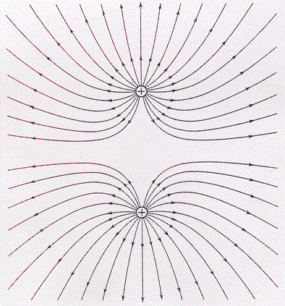 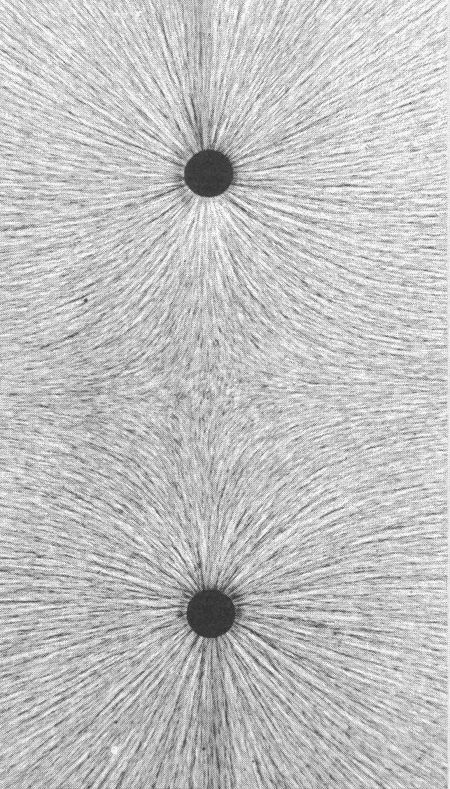

# Conductors and Electric Fields

In a conductor, electrons move freely until they reach a state of **static equilibrium** – i.e. all charges are at rest and experience no net force. For example, when a solid metal sphere is charged, either negatively or positively, all excess charges move as far apart as possible because of electrostatic forces of repulsion. The result is that excess charges distribute evenly on the surface of the sphere. The diagram to the right indicates the corresponding electric field lines created by the distribution of charge on the outer surface of a solid conducting sphere. Note that the electric field lines at the outer surface are always perpendicular to the outer surface.

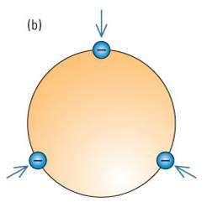

On a charged flat surface, the electrostatic forces of repulsion acting on charges cause the charges to spread and distribute evenly 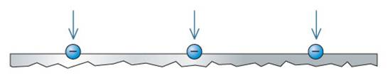along the outer surface. Electric field lines extend perpendicularly toward a negatively charged plate. The electric field lines are uniform and parallel.

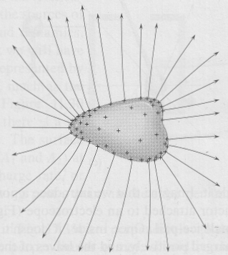For an irregularly shaped conductor, the charges still repel one another and accumulate on the outer surface. At a pointed part of a convex surface, the forces are directed at an angle to the surface, so a smaller component of the forces are parallel or tangential to the surface. With less repulsion along the surface, more charge can accumulate closer together. As a rule, the net electrostatic forces cause the charges to accumulate at the points of an irregularly shaped convex conducting object. Conversely, the charges will spread out on an irregularly shaped concave conducting object. On irregularly shaped conductors, the charge density and the electric field density is greatest where the surface curves most sharply. (Refer to Pearson pages 554 to 559.)

# Electric fields within conductors

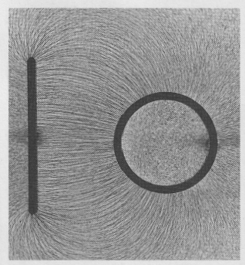Imagine a neutral conductor, solid or hollow, in a field–free region of space. Now suppose we add some electrons to it, either on the surface or inside. The mutual re­pulsion between free charges causes them to redistribute. The charges are initially bunched up, but very quickly they move apart and come to rest on the outer surface. The process generally only takes a fraction of a second, depending on the physical details of the conductor. Once settled, the distribution is such that each free charge experiences a zero net force – if it did not, the charge would accelerate until it could no longer move, and equilibrium would ultimately be established. If none of the charges experiences a net electric force, none of them is in an electric field. Since electric field lines either begin or end on charge, the field could only extend inside the conductor if there were a remaining excess of free charges there and that's impossible. **The electrostatic field inside a charged conductor, anywhere beneath the surface, is zero** – i.e. there are no electric field lines anywhere inside a hollow conductor. (In the picture to the right note that there is no field within the circular charged conductor.)

Michael Faraday dramatically proved the point by con­structing a room within a room, covering the inner enclosure with tinfoil. He sat in­side this Faraday cage, as it has come to be called, with an electroscope at hand, while the entire structure was charged by an electrostatic generator no field could be detected inside, even while sparks were flying outside.

# Practice problems

 = ?

•

P

B

+

A

+

1. The drawing to the right shows two charged objects A and B. Charge A produces an electric field at point P of 3.00 N/C to the right, and charge B produces an electric field at point P of 2.00 N/C down. What is the net field at P? (3.61 N/C @ 33.7o S of E)

2. What is the electric field strength at a distance of 6.0 cm from a point charge of -2.0 C? (5.0 x 106 N/C)

3. 2.4 x 1020 excess electrons are loaded on to the surface of a sphere with a diameter of 4.0 cm. What is the electric field intensity at a distance of 16 cm from the surface of the sphere? (Hint: What assumption is made to calculate the electric field of a sphere?) (1.1 x 1013 N/C)

4. A –40 C charge is placed into an electric field where it experiences an attractive force of 0.80 N. What is the electric field strength at that point? (2.0 x 104 N/C)

5. A proton is placed into an electric field near a positively charged sphere. If the electric field strength at the point where the proton is placed is 25 N/C directed away from the sphere, what is the acceleration of the proton? (+2.4 x 109 m/s2)

# Hand-in assignment

1. Draw the electric fields for the following situations:

+

–

+

+

–

–

–

+

a.

b.

c.

d.

2. Two hollow metal objects are charged by conduction with a negatively charged object. The cross-sections of the objects are shown below. Sketch the distribution of charge and the electric field lines surrounding both objects.

3. Why do we use a very small test charge to detect and measure the electric field?

4. Three small, negatively charge spheres are located on the vertices of an equilateral triangle. If the magnitudes of the charges are equal, sketch the electric field region around the charge distribution including the region inside the triangle. (What is the electric field strength in the center of the triangle?)

5. A metal sphere with a diameter of 10 cm has a charge distribution of 1.09085 x 1018 electrons/cm2 on its surface. What is the electric field strength at a distance of 25 cm from the surface of the sphere? What assumption is made to calculate the electric field of a sphere? (5.5 x 1012 N/C)

6. A small test charge of +1.0 C experiences and electric force of 6.0 x 10-6 N to the right.

a) What is the electric field at that point? (6.0 N/C right)

b) What force would be exerted on a charge of –7.2 x 10-4 C located at the same point, in place of the test charge? (4.3 x 10-3 N left)

7. What is the magnitude and direction of the electric field 1.5 m to the right of a positive point charge of magnitude 8.0 x 10-3 C? (3.2 x 107 N/C right)

8. What is the magnitude and direction of the electric field at point X in the diagram below? (5.8 x 105 N/C right)

•

X

+

_

60 cm

30 cm

q1 = -20 C

q2 = +8.0 C

9. An electron in an electric field experiences an acceleration of +4.39 x 1014 m/s2. What is the magnitude and direction of the electric field at this point? (-2.50 x 103 N/C)

10. Calculate the electric field at the center of a 35 cm square if one corner is occupied by a +38.0 C charge and the other three are occupied by -24.0 C charges. (9.10 x 106 N/C away from the +38.0 C charge)

11. What is the electric field at the center of a hollow metal sphere with a radius of 2.5 cm if the there are 2.0 x 1015 excess electrons on its surface?

12. An alpha particle is suspended at rest in a uniform electric field. Taking gravity into account, what is the electric field intensity? (2.03 x 10-7 N/C)

13. Measurements indicate that there is a weak electric field of 150 N/C surrounding the Earth which points into the center of the Earth. What is the magnitude of the electric charge on the Earth? Is it positive or negative? (6.77 x 105 C)